**AESOP- Creating Absence**

To Log in to AESOP go to [www.hempsteadschools.org](http://www.hempsteadschools.org)

Select Schools/Prospect School

Select the Teacher/Staff tab on the top

Select Frontline AESOP Management

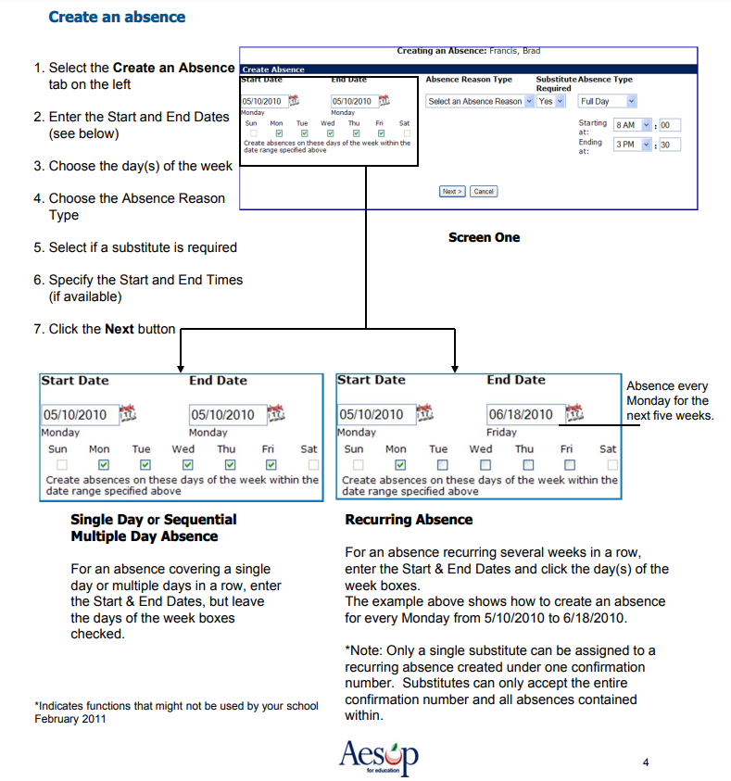Log in with your credentials. If you do not have credentials email crigalos@hempsteadschools.org

